Beacon Labs - Lab Report

Name: INSTRUCTOR | Date: (Date of lab completion)
Lab Name: Android Physical Input Hijacking (PHYjacking) Attack

Zip file of solution code is provided as well.

Setup:
(Description of the task and how you completed it. Include words and images as necessary)

Objective of this lab

Nowadays, most mobile devices are equipped with various hardware interfaces such as touchscreen, fingerprint scanner, camera and microphone to capture inputs from the user. Many mobile apps use these physical interfaces to receive user-input for authentication/authorization operations including one-click login, fingerprint-based payment approval, and face/voice unlocking. Our focus on this lab will be to mislead an unsuspecting user with a zero-permission malicious application to feed screen-touch and fingerprint input in order to unintentionally authorize a fund-transfer. This lab is based off of the paper PHYjacking: Physical Input Hijacking for Zero-Permission Authorization Attacks on Android by X. Wang, S. Shi, Y. Chen, and W. Lau.

Setting up IDE
• Follow the instructions listed within the lab document and submit a screenshot of your running emulated device with a fingerprint enabled in the security settings.
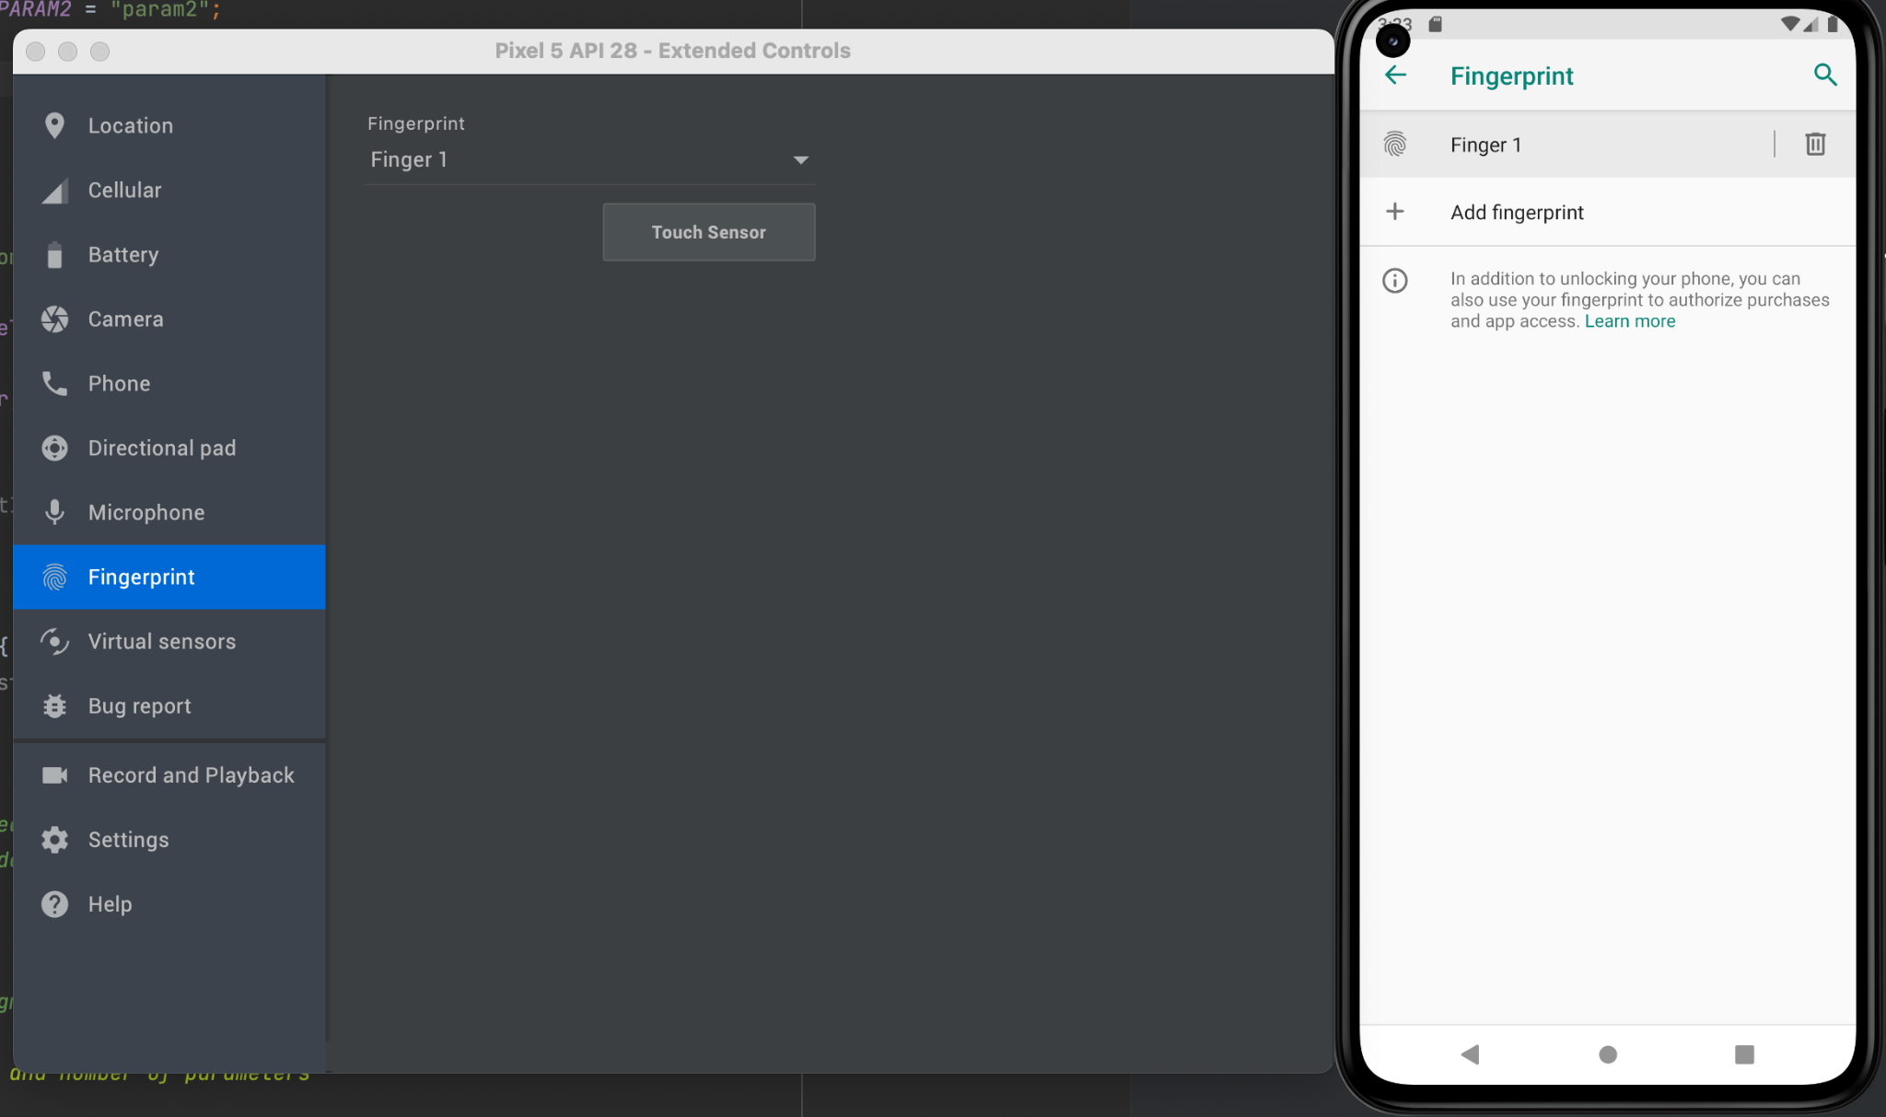
Task Set 1:
(Description of the task and how you completed it. Include words and images as necessary)

Task 1.1: Exploring the Vulnerabilities: Intent Flags
Action
1.1.1 Create a launch intent for the victim application, set the necessary flags, and submit a screenshot of your launchAttack() method.
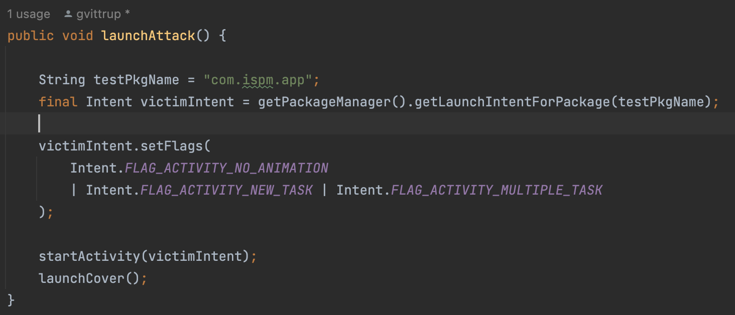

1.1.2 Create a launch intent for the covering activity, set the necessary flags, and submit a screenshot of your launchCover() method.
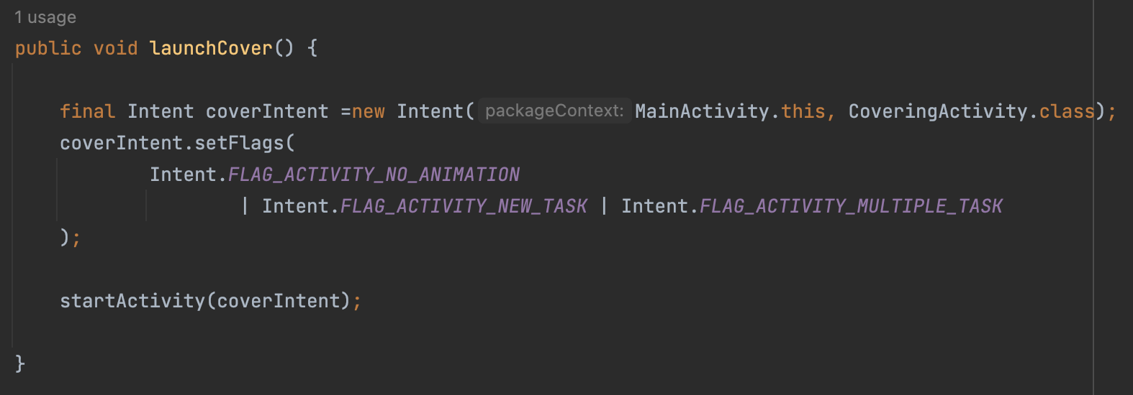

Task 1.2: Input Listener: Necessary Components (Touch Modals)
Action
1.2.1 Set the flags for your covering activity and submit a screenshot of your code.
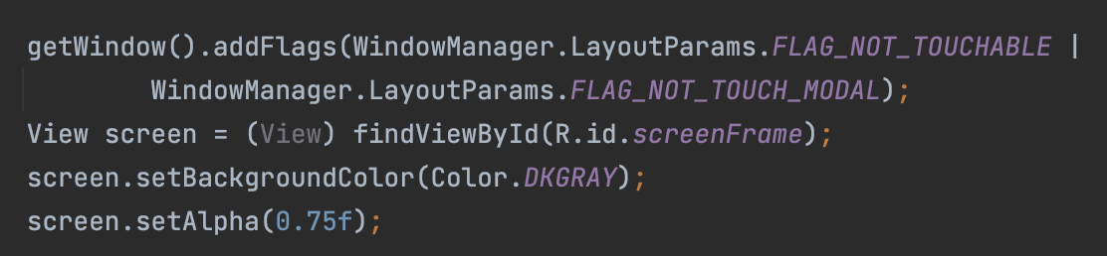

Task Set 2:
(Description of the task and how you completed it. Include words and images as necessary)

Task 2.1: Creating Instance Variable
Action
2.1.1 Create a class and a global variable to keep track of the number of screen transitions, and submit a screenshot of your code.
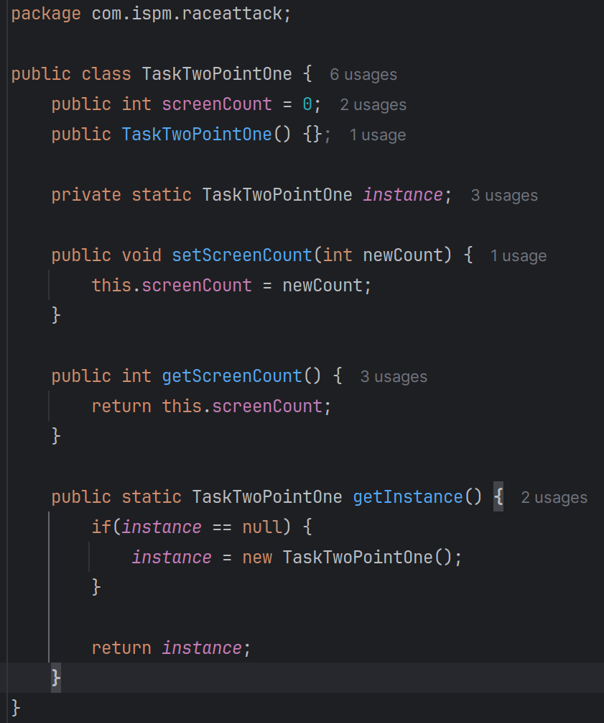
2.1.2 Update the onPause() function in CoveringActivity.java to increment and log the screenCount variable.
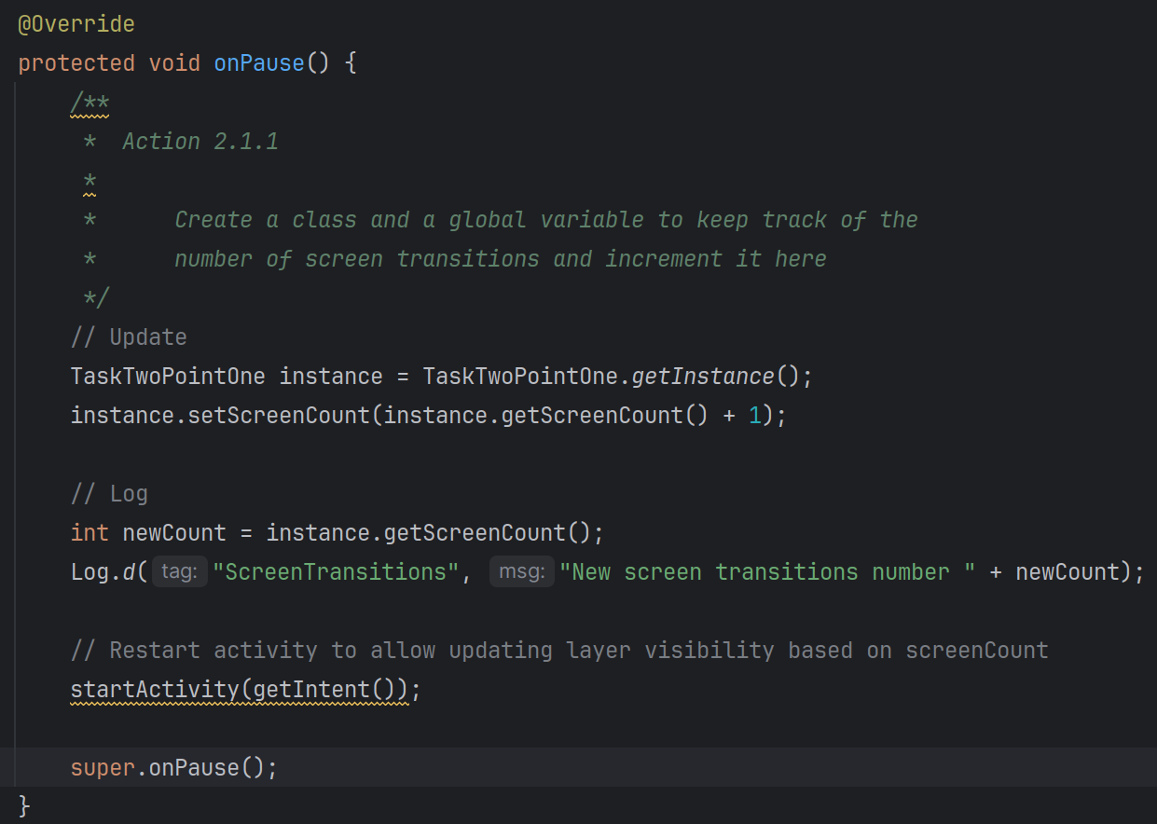
Task 2.2: Creating Overlay
Action
2.2.1 Create your navigational overlay and submit 3 screenshots from different sections of the page.
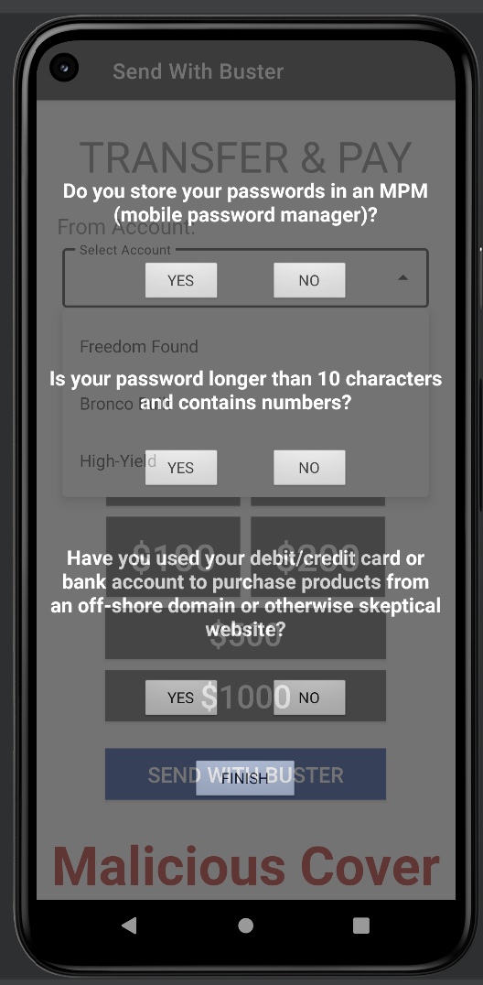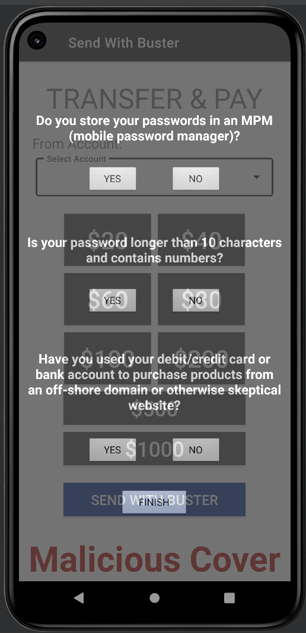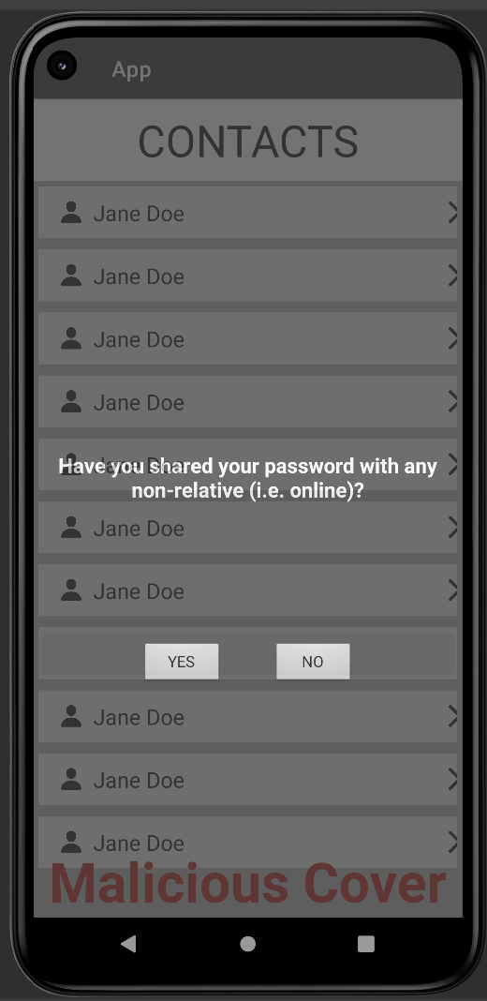
2.2.2 Create a fake lock-screen for the final destination of your overlay and submit a screenshot.
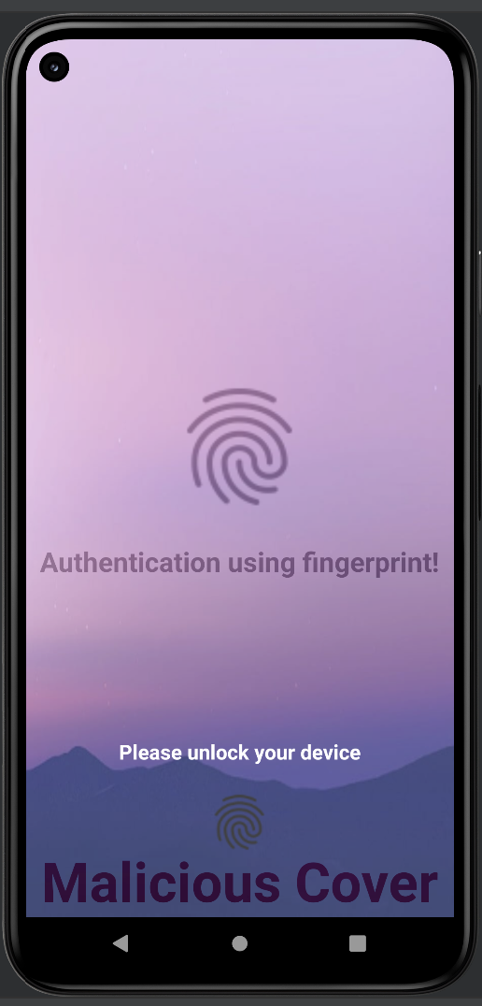
Task Set 3:
(Description of the task and how you completed it. Include words and images as necessary)

Task 3.1: Game Theory
Action
3.1.1 Calculate player 2’s pooling equilibrium; which strategy profitably deviates?
- $u(use)=0.75(3)+0.25(3)=1.5$
- $u(ignore)=0.75(-1)+0.25(-1)=-1$
- Using profitability deviates because it is 1.5 compared to -1
3.1.2 Calculate the value of σR, which represents player 2’s mixed equilibrium strategy. What is the probability that player 2 uses the app?
- $u(attack)=σ_{R}(-3)+(1-σ_{R})(1)$
- $u(no attack)=0+0=0$
$0=-3σ_{R}-σ_{R}+1$
$0=1-4σ_{R}$
$\frac{1}{4}=σ_{R}$
3.1.3 Calculate the value of P, which represents player 2’s belief that they are facing a vulnerable app. What is this probability?
- $u(use)=P(-3)+(1-P)(3)$
- $u(ignore)=P(-1)+(1-P)(-1)=-1$
$-1=-3P-3P+3$
$-1=3-6P$
$-4=-6P$
$\frac{2}{3}=P$
3.1.4 Calculate the value of $σ_{A}$, which represents the probability that the app is robust and player 1 chooses to attack.
$\frac{2}{3}=\frac{(0.25)(1)}{(0.25)(1)+(0.75)(σ_{A})}$
$σ_{A}=\frac{1}{6}$

Hints

Overlay
Try to keep it simple so the user wouldn’t get too annoyed by it and just quit the app or purposefully avoid doing what the overlay is attempting to do. The provided solution opted for a survey approach where the user has to click certain buttons, which just so happen to be right on top of the buttons to follow the path to making a transfer.

In other words, the overlay that is created by students should contain buttons or some other form of input that the user “needs” to press in order to clear/continue the overlay. These inputs should be placed on top of the input buttons that the target app uses to navigate through making a transfer. By doing so, the user will think they’re just following the overlay but in reality they’re making a transfer in the app. For the sake of the lab, we’re using a transparent background so you can see the target app being navigated as the overlay is being interacted with.

For help in making the overlay itself:
- Align elements with margins and the gravity flags.
- For icons use an ImageView element and when creating it click the + in the top left and select “Vector Asset”, select clip art, click the icon next to “Clip art:” to find all the built-in icons.
  - Most of, if not all, icons that are used in Android development can be found here.
  - If you want to use custom icons, tutorials can be found online on how to import a local SVG file or other file types.
- Do it one layout at a time, don’t try and stuff everything into one layout then set certain elements visibility at each step.
  - Create layouts for each step in the way, after each step is completed, set the currently visible layout to View.GONE and the layout for the next step to View.VISIBLE
  - Keep all layouts View.GONE by default and then update according to the screen transition count (updated in the onPause lifecycle function)

Game Theory
- Highly recommended to watch the William Spaniel video on Semi-Separating Equalibrium
  - The following videos in his Game Theory Series show some more examples of the concept as well
- For actions 3.1.2 and 3.1.3, the probabilities need to be set equal to each other
  - Just a system of equations problem once that’s realized by students

